**Listening N° 1: What would you like to order?**

**Name: Class: Date:**

Escuchar y demostrar comprensión de información explícita en textos adaptados y auténticos simples, en texto no literarios que estén enunciados en forma clara, tengan repetición de palabras y apoyo visual y gestual, y esténrelacionados con las funciones del año y los siguientes temas:

* La comida y la bebida.
* Temas de otras asignaturas.

**Objetivo de Aprendizaje 1**



**I. LOOK** at the picture and **WRITE** the name of the food in each bubble.

a)

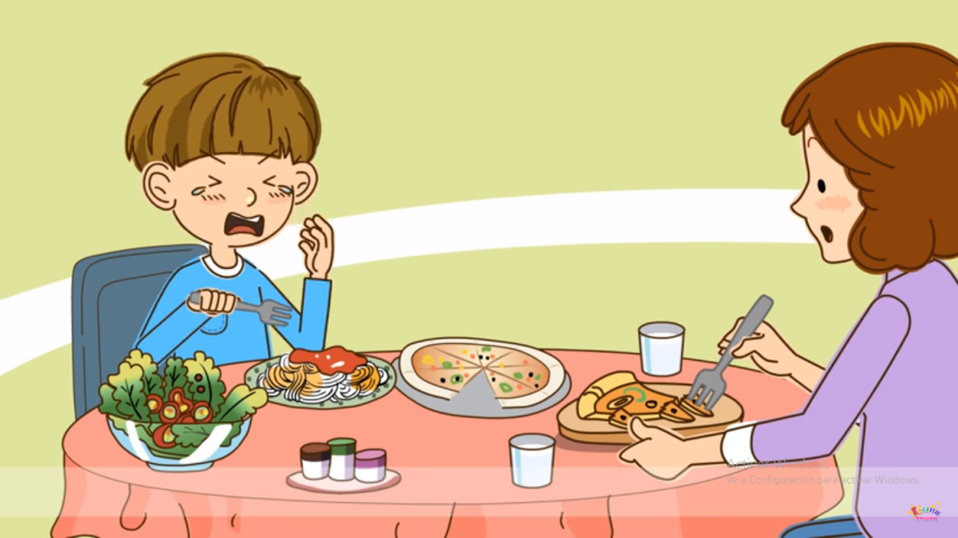

e)

b)

d)

c)



**II. ANSWER**  the question.

a) What kind of food are they eating?

------------------------------------------------------------------------------------------------------------------------------------------------------------------------------------------------------------------------------------------------------------------------------------------

**III. WATCH** the video and **ANSWER** the questions.

(Taken from: <https://www.youtube.com/watch?v=IWMMkp35d6Y>)

1. **What is the dialogue about?**



1. Ordering healthy food.
2. Ordering fast food.
3. Talking about favorite food.
4. **Where are these people talking?**
5. In a restaurant.
6. In the Street.
7. In a house.
8. **Who are these people?**
9. A grandmother and her son.
10. A son and his mother.
11. Two Friends.
12. **What did the woman order?**
13. A pizza and a spaguetti.
14. An ice cream.
15. A coffee and a lemon pie.

****Image result for headphones logo

**IV. LISTEN** to a song and **WRITE**  food that the kids like and don’t like.

(Taken From: <https://www.youtube.com/watch?v=qtLwSMivm2s>)

juice – chicken –apples – ice cream – rice – peach - fish - oranges

|  |  |  |
| --- | --- | --- |
| **LIKE** | **DON’T LIKE** | **DOESN’T SAY** |
|  |  |  |
|  |  |  |
|  |  |  |



**Pickles**

**Hamburger**

**V. WRITE** 5 sentences using the structure *I like/I don’t like.* **USE** some words from item I.**LOOK**  at the example.

**Example:**

I *like* strawberries.

**Example:**

I *don’t like* pizza.



|  |  |
| --- | --- |
| **Resultado de imagen para happy faceI LIKE** | **Resultado de imagen para sad faceI DON’T LIKE** |
| a) | a) |
| b) | b) |
| c) | c) |
| d) | d) |
| e) | e) |

